**Smart home and Smart city II**

This course continues on Smart home and smart city 1, to creating an ultimate smart home by using Raspberry Pi 3 Model B, Arduino, ESP8266, OpenHAB 2 and more to do home automation. Each course will be a different project and tutorial that student can follow to make your house more technologically advanced. This includes Amazon Echo voice recognition, switch control, light control, LED light strip, blinds control and door sensor. Students are required to have basic programming language knowledge and Python is preferred. Students will learn hands-on soldering, Linux Terminal command and electric knowledge during the course.

**Equipment and Pricelist:**

Raspberry Pi: $35

Arduino: $5

Additional Kit: $49

Includus: ESP8266, Raspberry Pi Box, Sonoff, LED strip, Door sensor, etc.

Video: <https://youtu.be/I-8QzW_thhY>

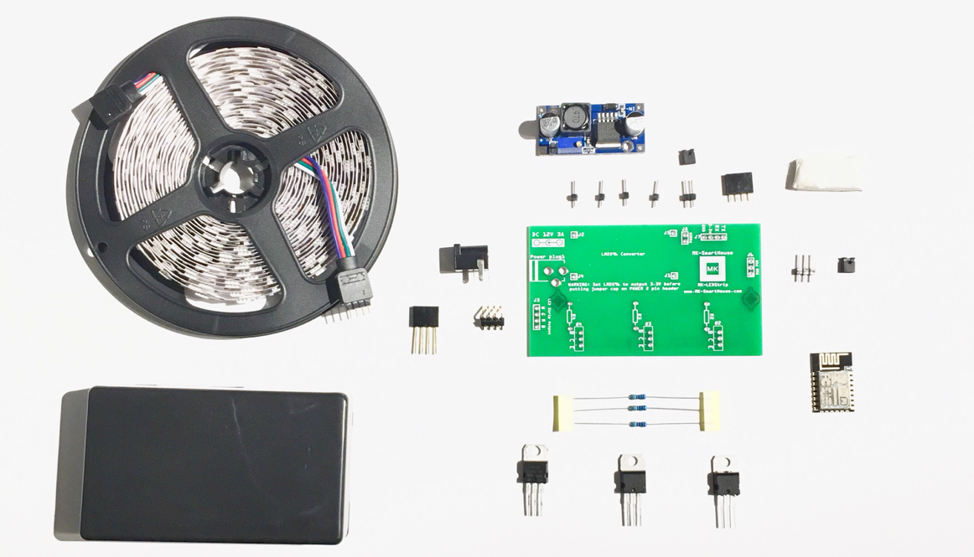

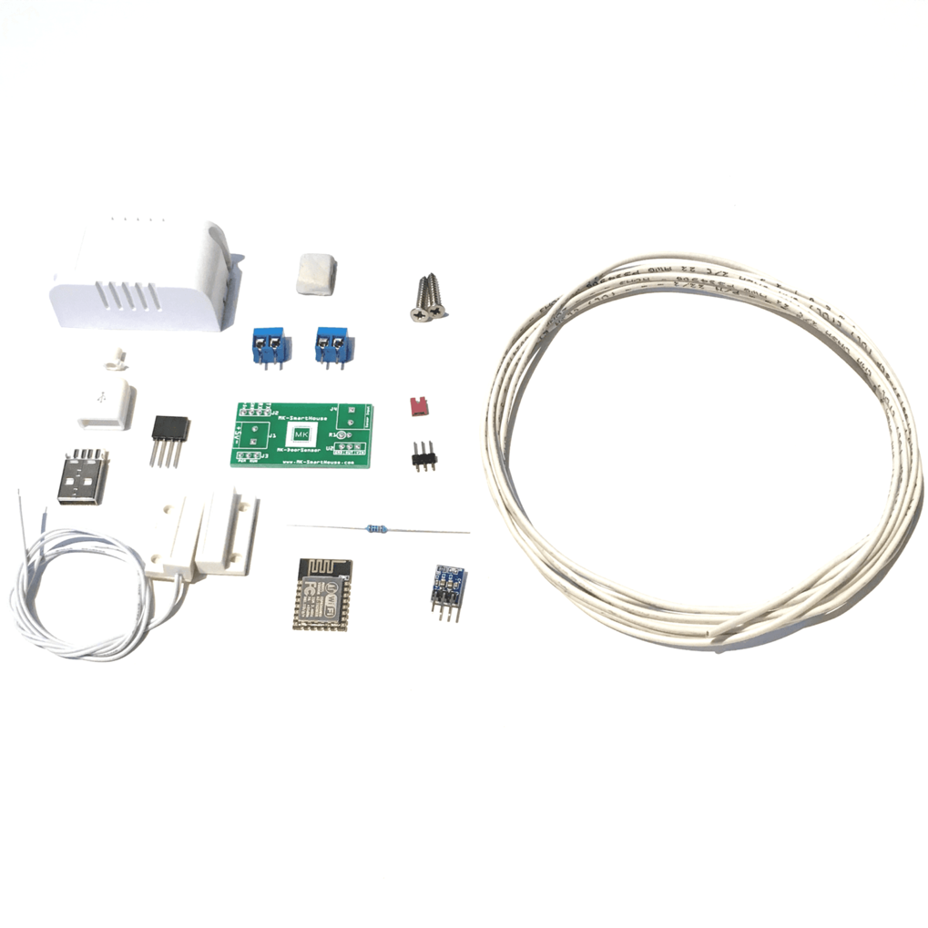

**Programming in Python 2:**

The python course starts from introducing a fancy python game. Each class will learn part of the technique necessary for building the game. At end of the course students are able to use the technique to build their own python games. The course includes basic python knowledge, function definition, file access, object-oriented programming and web scrapping. The course is fit for either non-programming language students or who have attend <Programming in Python 1>.